Creating a Collection
1. Open the Azure portal.
2. In the tree on the left, scroll down until you see RemoteApp. Click the RemoteApp feature (shown in Figure 7.5).
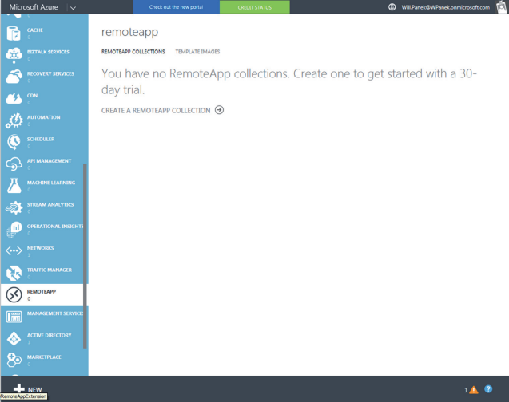
3. Click the Create a RemoteApp Collection link.
4. Click the Quick Create option and then enter a name for your collection (see Figure 7.6).
5. Select your region. If your region is not listed, choose the closest region to your own.
6. Select the billing plan you want to use. For this exercise, select the Basic package.
7. Finally, select the Office 2013 Professional image. This image contains Office 2013
apps. This image is good only for trial collections. You can’t use this image in a production
environment.
8. Click the Create RemoteApp Collection link.
